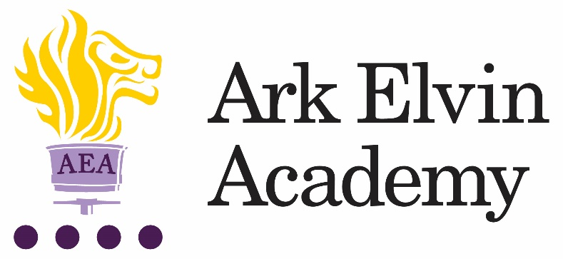

Job Description: Art Technician

The Role
To support the preparation and delivery of the curriculum for Art.
To ensure that the learning environment (classrooms and display boards) are up to date.

Key Responsibilities
- To prepare (and where appropriate manufacture) teaching materials, resources, and models as required to ensure effective support for teaching staff in the department
- To monitor standards and practices within the classroom and identify and communicate improvements to working practices to ensure the highest standards are achieved
- To assist with inventory of equipment and stock control in order to maintain a supply materials. Order stock as directed by the Head of Department so that resources are adequate for lessons
- To liaise with suppliers in the repair and maintenance of all machines and equipment
- To prepare and store materials in order to ensure classes are well equipped
- To receive and check deliveries of supplies to ensure accuracy from suppliers
- To provide technical assistance and information in the classroom and across the school community in order to support pupils and colleagues
- To support pupils in the classroom environment to assist in the learning process where appropriate
- To maintain well organised teaching and preparation rooms
- To maintain and create safe and tidy storage areas and storage systems
- To demonstrate practical making techniques to groups of students and teachers and be willing to learn new techniques and deliver as necessary
- To assist classroom teachers as directed to produce creative displays for the department that can be used to enhance classroom practice
- To work with the Head of Department to organise departmental safety audits
Other
- Undertake other responsibilities as directed by the line manager.

Person Specification: Art Technician
Qualification Criteria
- Right to work in the UK
- Qualified to degree level or proficient to A-Level standard in art
Knowledge and Experience
- Awareness of the latest Health & Safety regulations
- Experience of working with secondary school aged children
- Use of Microsoft Word, Excel, PowerPoint and photoshop
- Knowledge of health and safety requirements, to ensure a consistently safe working environment

Personal Characteristics
- Genuine passion and a belief in the potential of every pupil
- Ability to relate to young people and adults in the learning environment
- Helpful, positive, calm and caring nature
- Respectful of different experiences, ideas and backgrounds of the members of the whole school community
Skills and attributes
We are looking for these skills and attributes or at the very least, a candidate’s clear, demonstrable capacity to develop them:

Alignment with Elvin vision
- Relentless drive to do whatever it takes to ensure all pupils succeed.
- Embody our core values – integrity, courage, community and mastery – in all aspects of work and conduct.
- The belief that with the right environment all of our pupils are able to excel at university, or in a meaningful alternative.
- The courage and conviction to make a difference.

Communication skills
- The ability to listen and communicate effectively.
- Empathy and the ability to understand the needs, aspirations and motivation of diverse individuals and groups.
- The ability to influence and motivate others.

Working with others
- Develop and communicate a shared vision.
- Model desired behaviour and values.
- Empower, support and coach others.
- Hold others to account for high standards of performance.
- Understand and resolve conflict.

Problem solving
- Identify, analyse and resolve problems and issues.
- Develop plans with concrete outcomes and effective solutions.
- Evaluate results and identify necessary actions.
- Make fact-based decisions.

Resilience
- Sustain energy, optimism and motivation in the face of pressure and setbacks.
- Stay calm in difficult situations and maintain clarity of vision.
- Be adaptable in the face of adversity.

Results and learning orientation
- Awareness of own strengths and limits.
- Commitment to ongoing improvement and learning.
- A passion for own role and that of others.
- Focus on achieving challenging goals and results.
- Resourcefulness and flexibility in delivering outcomes.

Leadership
- Effective team worker and leader.
- Demonstrates resilience, motivation and commitment to driving up standards of achievement.
- Acts as a role model to staff and students.
- Vision aligned with Elvin’s high aspirations, high expectations of self and others.

Other
- The post holder must be committed to the safeguarding and welfare of all pupils.
- Willingness to undertake training.
- This post is subject to an enhanced Disclosure and Barring Service check.

Ark is committed to safeguarding and promoting the welfare of children and young people in our academies. To meet this responsibility, we follow a rigorous selection process, details of which can be provided if requested. All successful candidates will be subject to an enhanced Disclosure and Barring Service check.

