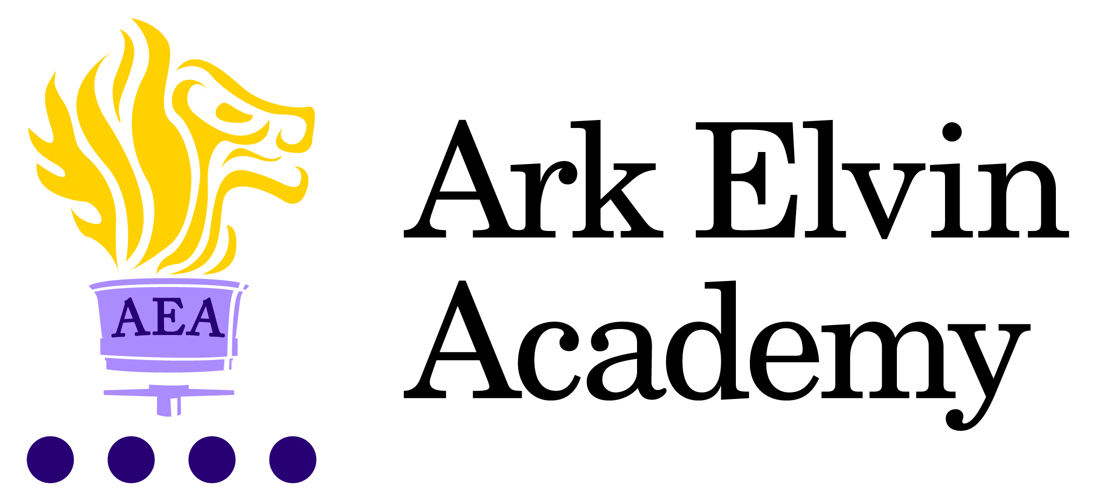

Job Description: HR Advisor

Reporting to: Principal
Start date: ASAP
Location: Ark Elvin Academy
Contract: Full-time, permanent (36 hours per week) – Working hours to be agreed with line manager.
Salary: Ark Support Staff Scale Grade 8, points 19 to 29 – salary range £34,452 to £40,427 (FTE equivalent)

The Role
As an integral member of the operations team, you will lead on the day-to-day HR service provision across the academy. You will manage HR administration and provide a high quality and confidential advisory HR service. This role requires the post holder to be capable of operating with high levels of autonomy, although you will be supported by your line manager and the Regional People Business Partner, as well as a central “AskHR” service.

Key Responsibilities
Recruitment and Selection
- Co-ordinate and manage recruitment and induction processes in accordance with safer recruitment and Ark HR policies across the Academy.
- Manage relationships with relevant recruitment agencies and the Ark central HR and recruitment teams, ensuring the most cost-effective provision of staffing for the Academy.
- Ensure all pre-employment checks, including right to work checks, are carried out in line with safer recruitment guidance, and that the Single Central Record is accurate and up to date at all times.
- Ensure a meaningful induction and probation process is in place for all new starters.
Employee Relations, Policies and Procedures
- Provide advice and guidance on the implementation of Ark HR policies and procedures, liaising with the central HR team as required.
- Advise on employee relations issues; process and manage related casework.
- Develop trusted relationships with colleagues across the school and network.
- Support with workforce planning across the academy.
- Implement/support staff wellbeing initiatives.
- Implement/support employee engagement initiatives.
Data Management and Reporting
- Manage the HR Information System (BROMCOM), ensuring electronic employee records are accurate and training other staff on its use as required.
- Maintain an accurate Single Central Register (SCR), keeping up to date with legislation, in accordance with current Ofsted requirements.
- Co-ordinate the Academy’s School Workforce Census annual return
- Support with data entry on other school systems such as Inventory, parent pay etc.
- Produce reports as required.

Performance Management, Appraisal and Staff Training
- Support line managers through the performance management process as required.
- Co-ordinate and monitor the completions of performance management processes.
- Develop and maintain a staff training record of statutory training.

Compliance
- Ensure compliance with current employment law, HR best practice and Ark HR policies and procedures.
- Oversee absence management, including reporting and recording processes.
- Take responsibility for ensuring that the probation process is managed effectively.

Payroll and Pension Administration
- To work closely with the Finance Manager in processing payroll and pension administration
General HR Administration
- Maintain an accurate paper and electronic filing system for personnel records.
- Complete a range of HR related paperwork and produce high quality, accurate HR letters.
- Process staff changes, staff leaving documentation and arrange exit interviews.
- Monitor the use of fixed term contracts and ensure that issues are followed up.
- Monitor probation periods, ensuring compliance with Ark probation policy.
- Assist and support on HR projects as and when required.

Other
- Carry out other reasonable tasks as directed by your line manager.
- Work with Regional People Business Partner, Ark Central and other academies in the Ark network, to establish good practice throughout the network, offering support where required
- Assist the Central HR Manager with HR support and provide training to other Academies as required.

Person Specification: HR Advisor

Qualifications
- Right to work in the UK
- GCSE at grade C or above in English and Maths
- HR qualification (ideally CIPD Level 5 or above) or other relevant HR qualification or working towards it.

Knowledge, Skills and Experience
- Experience of working in HR and using a HR Database.
- Experience of working in a similar role in a school environment (Highly Desirable)
- Good IT skills, highly competent using Microsoft Office.
- Strong administrative and organisational skills
- Excellent written and oral communication skills.
- Line management or supervisory experience
- Understanding of relevant legislation, policies and procedures, and the ability to apply this understanding to real situations.
- Ability to provide initial advice or guidance to managers.

Personal Characteristics
- Genuine passion for and a belief in the potential of every pupil
- Deep commitment to Ark’s mission of providing an excellent education to every student regardless of background.
- Attention to detail.
- Professional outlook detailed orientated and able to multitask and meet deadlines.
- A team player that can work collaboratively as well as using own initiative.
- Ability to stay calm and diplomatic under pressure.
- Understanding of the importance of confidentiality and discretion
- Flexible attitude towards work and demonstrates sound judgement.

Other
- Commitment to equality of opportunity and the safeguarding and welfare of all students
- Willingness to undertake training.
- This post is subject to an enhanced DBS check.

Ark is committed to safeguarding and promoting the welfare of children and young people in its academies. In order to meet this responsibility, its academies follow a rigorous selection process to discourage and screen out unsuitable applicants. ​
​
Ark requires all employees to undertake an enhanced DBS check. You are required, before appointment, to disclose any unspent conviction, cautions, reprimands or warnings under the Rehabilitation of Offenders Act 1974 (Exceptions) Order 1975. Non-disclosure may lead to termination of employment. However, disclosure of a criminal background will not necessarily debar you from employment - this will depend upon the nature of the offence(s) and when they occurred. To read more about Ark’s safer recruitment process, please click this link.

