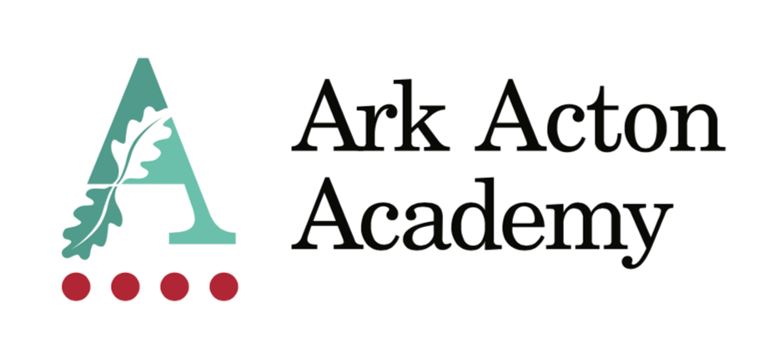

Appointment to the post of
Teacher of Social Sciences

Information for Applicants

April 2024

Dear Applicant,

Thank you for taking the time to find out more about Ark Acton Academy. This pack is intended to give you information about the role of teacher of Social Sciences, together with details of the Academy’s vision and ethos and our aspirations.

In the words of Christine Counsell, without knowledge of one’s own past, one cannot live as a human. All our thoughts and acts are tissued with memory. Without knowledge of a collective past, we cannot think or act socially or politically. That is why knowledge of Social Sciences is emancipatory. Only when young people can generalise appropriately, draw on enough precedent to give explanatory power to their argumenta and share enough common terms of reference to challenge the grounds of others’ generalisations and arguments can they hope to engage with educated discourse and especially serious political discourse.
At Ark Acton we believe therefore that the principal function of Social Sciences is to develop ‘historically literate’ pupils who do not view the past as dead and fixed but as a means to examine the world and what it means to be human. As they progress through KS3 and into KS4 and 5, students learn to orient themselves in time and critically contextualise issues of the past to see their relevance today.

To do this, our curriculum aims to develop:

- An extensive general knowledge of the past underpinned by a strong understanding of historical concepts, such as Empire.

- Strong conceptual understanding, underpinned by second order concepts such as interpretations.

We also need to understand that Social Sciences should serve to develop inclusive communities, one where pupils can affirm their emerging identities with the curriculum and see their learning as meaningful. To do this, our curriculum incorporates world Social Sciences, such as the Mali Empire, local Social Sciences such as the Industrial Revolution and Acton and a Social Sciences of migration over time.

We therefore aim to ensure that both substantive and disciplinary knowledge work to serve one another and to ensure that our students come to see the past as a contested space; where knowledge does not arrive in fixed stories that can never be reconfigured, challenged, or defended.
At Ark Acton we have stripped away anything we feel gets in the way of being a great teacher so that we can focus on the main thing. This includes:

- Feedback policies that sit at department level
- No graded lesson observations
- No report writing
- No parent’s evenings
- Only 2 data points a year
- No ½ termly data metrics to track progress
- Protected Department meeting time built into the timetable.

We are heavily committed to staff welfare and development and this includes:

- weekly staff training
- Coaching for every teacher
- each member of staff has a personal development pathway to help ensure they have the feedback and space necessary to keep improving
- free use of our leisure centre
- access to the school counsellor

We place the curriculum – what we teach – at the heart of the academy and it informs all decisions we make. We are looking for someone who shares our belief in disciplinary thinking and who will help improve and refine our curriculum thinking.

In the words of Alex Standish we believe that “school subjects then are a way of inducting children into the intellectual habits of humankind, and hence into a disciplinary conversation about knowing our world” and we are looking for someone who shares this belief to join our team.

I look forward to receiving your application and welcoming you to our Academy.

Yours sincerely,

Oli Knight
Principal

Teacher of Social Sciences – Job description

Job Title: Teacher of Social Sciences

Reports to: Head of Social Sciences

Responsible for: Delivering the highest quality learning experiences to pupils in the Social Sciences Department.

Start date: September 2024

Salary: Main Scale (Ark Inner London)

Disclosure level: Enhanced

Roles included: Classroom teacher, Form Tutor

Job purpose

To contribute to developing Ark Acton Academy into a great school by teaching a challenging Social Sciences curriculum (GCSE and A Level Sociology and A-Level Psychology), teaching highly effective sequences of lessons, and constantly reflecting on your practice.

Objectives

- To deliver consistently excellent sequences of lessons to pupils to enable them to develop a deep understanding of the subject.
- To support the development of a knowledge-led disciplinary curriculum.
- To take responsibility for proactive personal professional development to build own capabilities continuously.
- To constantly reflect on your practice and commit to the multiple layers of training and development available at Ark Acton.
- To make a valued contribution to the school’s pastoral and enrichment programmes; including trips and school visits.
- To hold, as an effective Form Tutor, responsibility for and a ‘single-view’ of each pupil in the tutor group and strive to become a true mentor to every pupil.
- To epitomise the vision and values of Ark Acton Academy and at all times adhere to the staff code of expectations.

Principal Accountabilities

PLANNING AND DELIVERY OF LESSONS

- Plan and deliver high-quality and challenging sequences of lessons.
- Ensure planned sequences of lessons respond to results of assessment, reporting and monitoring.
- Facilitate a learning environment that provides every pupil with an opportunity to achieve his or her potential, including building relationships and managing behaviour effectively to maintain an excellent standard of discipline at all times and a classroom atmosphere that is conducive to work.
- Prepare and present pupils for any internal or public examinations, as directed, in a manner that enables each pupil to achieve his or her potential.
- Maintain high expectations of your pupils and set them challenging but achievable targets.
- Understand your responsibilities for pupils with particular needs, including your responsibilities under the SEN Code of Practice. These will include identifying pupils with special educational needs, adapting your teaching accordingly, seeking advice from the SENCO when appropriate, and maintaining adequate records to enable you to feed into whole-school and external reporting.
- Follow all relevant school and departmental policies in the planning and delivery of lessons.

ASSESSMENT, REPORTING AND COMMUNICATION

- Implement the Academy approach to marking and feedback to inform planning, develop learning and evaluate pupils’ progress.
- Make effective and regular use of the Academy’s assessment criteria and reporting procedures to inform learning.
- Set targets for raising pupil attainment in the context of whole school targets and work towards their achievement.
- Maintain regular records of pupils’ attainment and progress.
- Attend parents’ evenings and Open Evenings as required.
- Assess how well learning objectives have been achieved and use this assessment and Academy provided data on a regular basis for future teaching and target-setting, as well as implementing strategies to address pupil underachievement.
- Liaise with external agencies about individual pupils as required.

PROFESSIONAL DEVELOPMENT

- Take responsibility for your own professional development and demonstrate a commitment to continuous professional development by undertaking, and seeking out, opportunities to build your capabilities as a teacher.
- Maintain an up-to-date expert knowledge of your subject area, related teaching pedagogy and relevant aspects of the National Curriculum, exam board requirements and other statutory provisions, including developments and reforms in broader education policy.
- Ensure you understand your professional responsibilities in relation to school policies and practices.
- Evaluate your own teaching critically and use this to improve your effectiveness.
- Support colleagues when working in your teacher learning communities.

NON-SUBJECT RESPONSIBILITIES

- Demonstrate consistently high expectations of all pupils and a commitment to raising their achievement and social and emotional wellbeing. Promote the positive values, attitudes and behaviour expected from all pupils by treating them with respect and consideration.
- Develop strong and positive relationships with pupils.
- Implement all Academy policies, including the Academy’s behaviour policy.
- Contribute to the design and delivery of the Academy’s enrichment curriculum in line with your timetable and the Ark Acton enrichment policy.
- Model the ethos and vision of the Academy at all times.
- Communicate promptly and sensitively with parents, carers and other relevant bodies where necessary.
- Contribute to the Academy’s liaison, marketing and pupil recruitment activities, e.g. the collection of material for press releases.
- Help to develop effective subject links with partners and the community, including attendance where necessary at liaison events in partner Schools and Academies and the effective promotion of your subject at Open Days/Evenings and other events.
- Establish and maintain effective working relationships with colleagues including support staff.
- Be familiar with and comply with the Academy’s Health and Safety policies
- Be responsible for the health & safety of pupils when they are authorised to be on Academy premises and when engaged in authorised activities elsewhere
- Adhere, at all times, to the expectations of teachers at Ark Acton Academy, outlined on the final page of this document.
- Any other duties as required by the Headteacher commensurate with the post.

No job description can be fully comprehensive, and from time to time the successful candidate may have to undertake other professional duties as directed by the Headteacher/ Deputy Headteacher.

Person Specification

 | Essential | Desirable
Qualifications | - Qualified to at least degree level in the subject being taught.  - Qualified to teach in the UK.  - Qualified to work in the UK.  - QTS. | - Further professional qualifications.  - Experience of teaching A Level in this subject.
Experience | - Ability to deliver consistently outstanding lessons in this subject to pupils of all ages and abilities.  - Proven record of significantly raising achievement with all groups of pupils across the age and ability range and of helping them achieve impressive examination outcomes.  - Proven commitment to continued professional development and a readiness to reflect and self-evaluate to change, improve and develop. | - Experience of having worked successfully in at least one school in an urban, multi-cultural setting, teaching pupils from backgrounds of socio-economic disadvantage.  - Successful experience of working particularly with high ability or SEN pupils.
Knowledge | - Thorough knowledge of the requirements of the National Curriculum in the subject.  - An understanding of the ways that cognitive science can improve teacher effectiveness.  - An understanding of the strategies needed to establish consistently high aspirations and academic / behavioural standards in an urban school setting, and a commitment to relentlessly implementing these strategies.  - Knowledge & experience of Safeguarding & Child Protection issues. | - Thorough knowledge of Key Stage 4 and Key Stage 5 specifications in the subject.  - Actively informed of developments in your subject area, and of broader pedagogic developments at local, national and international levels.
Skills | - Excellent interpersonal and listening skills; a high degree of emotional intelligence; and an effective oral and written communicator with children, staff and parents.  - The ability to develop positive relationships with all young people.  - Well developed planning & organising skills including time management, prioritisation, delegation and administration.  - Sound judgement and problem solving skills. | - An ability and willingness to teach across more than one subject.  - A proven ability to use data confidently and forensically to inform and diagnose weaknesses that need addressing, and ability to plan effectively in order to raise individuals’ and cohorts’ attainment.  - Competent user of ICT.
Motivation | - Willing to be fully engaged in the whole life of the school including extra-curricular activities.  - Willing to be a form tutor.  - Committed to team work and working collaboratively with colleagues.  - A commitment to the safeguarding and welfare of all pupils. | - Experience of leading successful enrichment and extracurricular activities, which inspire and motivate learners.
Attributes | - A clear passion for your subject.  - The ability to enthuse and inspire others.  - Passion, resilience, maturity and optimism to lead through day-to-day challenges while maintaining a clear strategic vision and direction.  - Confidence and self-motivation to work well and be decisive under pressure.  - A high level of honesty and integrity.  - Personal stamina & energy including a good record of attendance and health.  - A firm and constant belief in the unlimited potential of every pupil and a commitment to inclusive educational provision. | - An entrepreneurial attitude.

Ark is committed to safeguarding and promoting the welfare of children and young people in its academies. In order to meet this responsibility, its academies follow a rigorous selection process to discourage and screen out unsuitable applicants.
Ark requires all employees to undertake an enhanced DBS check. You are required, before appointment, to disclose any unspent conviction, cautions, reprimands, or warnings under the Rehabilitation of Offenders Act 1974 (Exceptions) Order 1975. Non-disclosure may lead to termination of employment. However, disclosure of a criminal background will not necessarily debar you from employment - this will depend upon the nature of the offence(s) and when they occurred. To read more about Ark’s safer recruitment process, please click this link.
Ark Schools are committed to attracting, developing and retaining a diverse workforce, with a broad range of backgrounds, experiences and perspectives. To read more about Ark’s diversity and inclusion statement, please click this link.

