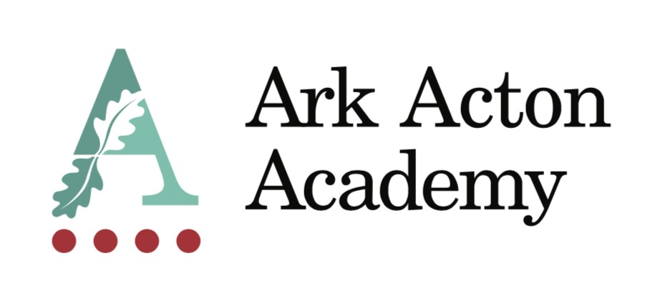

Appointment to the post of Learning Support Assistant

Information for Applicants

September 2020

Dear Applicant,

Thank you for taking the time to find out more about Ark Acton Academy. This pack is intended to give you information about the role of Learning Support Assistant, together with details of the Academy’s vision and ethos and our aspirations.

Ark Acton Academy is on an incredible improvement journey and we are sowing the seeds of greatness for our local community. However, there is still much to do and we are looking for someone with a deep passion for curriculum thinking who can help drive us forwards. You will share our firm belief in the importance of disciplinary curriculum thinking and you will want to join a school that invests in its staff.

We are heavily committed to staff welfare and development and this includes:

- local discounts, dry-cleaning service
- Access to a range of discounts through the Ark Rewards Scheme which includes reduced gym memberships, discounts at major retailers and travel loans
- weekly staff training
- free use of our leisure centre
- access to the school counsellor
- Commitment to CPD

In the words of Alex Standish we believe that “school subjects then are a way of inducting children into the intellectual habits of humankind, and hence into a disciplinary conversation about knowing our world” and we are looking for someone who shares this belief to join our team.

I look forward to receiving your application and welcoming you to our Academy.

Yours sincerely,

Oli Knight
Principal

Job Description: Learning Support Assistant

Reporting to: SENDCo
Location: Ark Acton Academy
Contract: Permanent
Working Pattern: Term Time
Salary: Ark Support Scale 5 £22,800 (Pro rata)

Job Description
The Role
To work with the SENCO to provide tailored support to pupils who have special educational needs and/or disabilities. Learning Support Assistants play a vital role in supporting pupils, both in a one to one setting and in larger and whole class groups.
Key responsibilities
- To plan tailored interventions for individual pupils.
- To provide in class support for pupils, as directed by the SENCO and class teachers.
- To support pupils with Special Educational Needs (SEN) outside of the classroom in a wide variety of settings including assessments, small group interventions (e.g. phonics) and supervision/leadership of activities in break times, lunch, after school clubs as well as on trips and residential trips
- To maintain and actively promote high academic and behavioural expectations across the academy
- Support staff members in creating an effective and safe learning environment.
- To work with class teachers to plan support in lessons.
- To liaise with families to gain a thorough understanding of the needs of pupils.
- To update pupil records as required.
- To assist student/s with their physical/personal care/medical needs as required.
- To share information about individual pupils with teachers and other colleagues so that all colleagues understand differentiation needs and how best to support learners.
- To prepare additional resources for pupils as required.
- To carry out duties around the school to support the smooth running of the school and promote school values.
Other
- Undertake other various responsibilities as directed by the Principal
- Actively promote the safety and welfare of our children and young people
- Ensure compliance with Arks data protection rules and procedures
- Liaise with colleagues and external contacts at all levels of seniority with confidence, tact and diplomacy

This job description sets out the main duties of the post at the time of drafting. It cannot be read as an exhaustive list. These responsibilities will be discussed annually as part of the postholder’s annual performance review and are subject to change. However, it may be altered at any time subject due to organisational need in consultation with the postholder and line manager and with Principal’s approval.

Person Specification
Qualification criteria
Essential:
- Right to work in UK
- Good literacy and numeracy
- GCSE (or equivalent) in English, Maths and Science at grade B or above
Desirable:
- HLTA qualification
- First aid qualification
- Specific training in one or more of the four areas of need outlined in the SEND Code of Practice
Essential experience
- Experience of establishing successful learning relationships with a variety of children at the relevant age
- Experience and/or understanding of the role of a learning support assistant
Desirable:
- Experience of running small group interventions, e.g. Fresh Start Phonics
- A working knowledge of the SEND Code of Practice
Behaviours, skills and attributes
Personal characteristics
- Proactive, reflective and committed
- Passionate about the potential of every pupil
- Able to establish and maintain excellent working relationships with staff, pupils and parents
- Able to follow instructions accurately but make good judgments and lead when required
- Motivated to continually improve standards and maintain high expectations for all pupils
- Sustain energy, optimism and motivation in the face of pressure and setbacks.
- Resourcefulness and flexibility in delivering outcomes.
- Acts as a role model to staff and students.

Specific skills
- Excellent communication skills, orally and in writing.
- Competent with computers and other technology
- Good administrative and organisational skills
- Able to understand and implement particular strategies and methods to help pupils to improve their learning and enjoyment of learning including leading specific interventions
- Able to understand and implement the necessary routines and patterns to establish good behaviour in the school
- Able to deal with minor incidents, first aid, and the personal health and hygiene of the pupils
- Understands the importance of confidentiality and discretion

This post is subject to an enhanced Disclosure and Barring Services check
The post holder must be committed to safeguarding the welfare of children.

