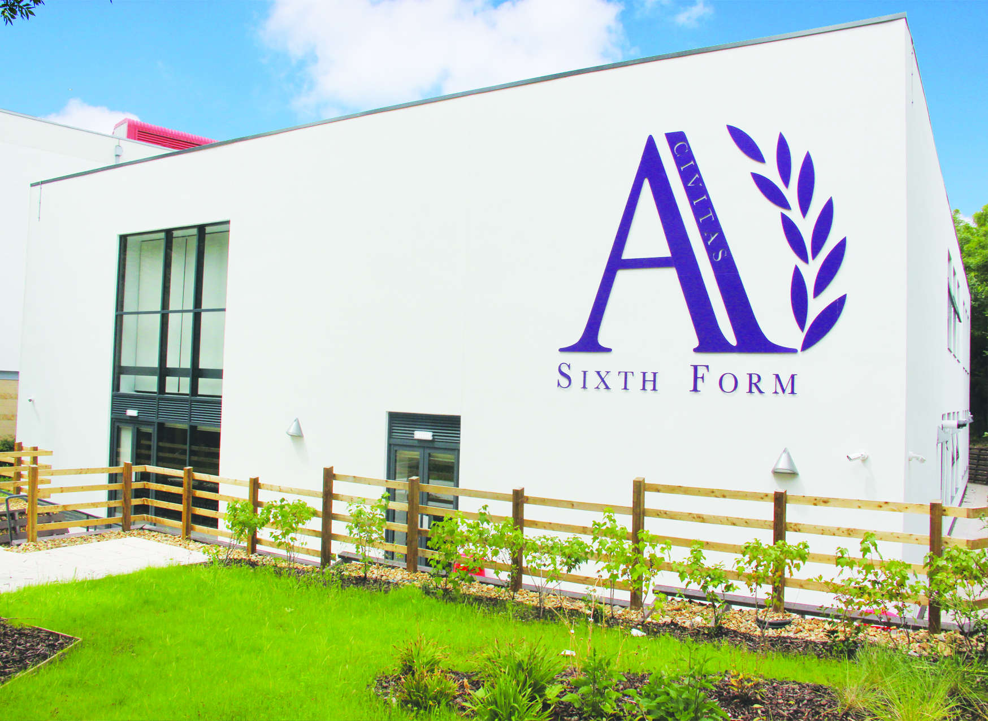

Opportunity to join an ‘Outstanding’ all-through academy specialising in mathematics and citizenship.
HEAD OF DEPARTMENT MFL

Candidate
Information
Pack

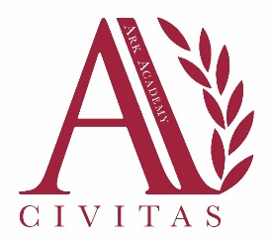

November 2019
Dear Candidate
We are looking to recruit a talented and inspiring teacher who is committed to helping our students fulfil their potential.
We are very proud of our reputation for academic excellence and also the superb pastoral care our students receive along with the support we provide for the less academically able. We now want your help to enable us to go beyond outstanding and achieve ‘excellence for all’.
The MFL Faculty is well-resourced and fully staffed. The Academy has an excellent record of support for professional development and there is a comprehensive programme of support for NQTs
To apply, follow the link at https://arkacademy.org/vacancies by 9:00am on Monday 18 November 2019. For an informal, conversation about the role, please contact Denise McKenna 020 8385 4370 or d.mckenna@arkacademy.org
We wish you the best with your application
Delia Smith OBE
Principal

Job Description: Head of MFL
Reporting to: Member of SLT
Start date: Easter 2020
Salary: APS + TLR1a

The Role
To manage and lead the subject teachers within the department to ensure the highest student progress and attainment

To develop and lead an exciting curriculum which engages and inspires students

Key Responsibilities
- Subject coordination across the academy and leadership of team
- Monitoring and accountability for the progress and attainment of students in MFL
- Curriculum design and assessment across the academy as agreed with the SLT

Outcomes and Activities
Leadership of the subject community
- Excellent classroom teacher with the ability to reflect on lessons and continually improve their own practice
- Prepare pupils for external examinations
- Establish a department development plan and monitor and evaluate its delivery and effectiveness
- Manage departmental budget and resources effectively and efficiently
- Direct and supervise support staff assigned to lessons and when required participate in related recruitment and selection activities
- Implement and adhere to the academies behaviour management policy, ensuring the health and well-being of pupils is maintained at all times
- Maintain regular and productive communication with pupils, parents and carers, to report on progress, sanctions and rewards and all other communications

Curriculum setting and assessment
- Develop a syllabus and schemes of work for all year groups, in line with exam board requirements, that are inspiring for learners and teachers alike
- Monitor and assessment of teaching and learning
- Set regular, measurable and significant assessments for the students
- Establish agreement for monitoring and evaluation of student progress
- Maintain accurate pupil data that can be used to make teaching more effective
- Produce/contribute to oral and written assessments, reports and references relating to individual and groups of pupils

Academy Culture
- Support the academies values and ethos by contributing to the development and implementation of policies practices and procedures
- Help create a strong academy community, characterised by consistent, orderly behaviour and caring, respectful relationships
- Help develop an academy culture and ethos that is utterly committed to achievement
- Support and work in collaboration with colleagues and other professions in and beyond the school, covering lesson and providing support as required.

Other
- Undertake, and when required, deliver or be part of the appraisal system and relevant training and professional development.
- Undertake other various responsibilities as directed by members of the SLT or Principal

Person Specification:
Head of MFL

Qualification Criteria
- Qualified to degree level and above
- Qualified to teach and work in the UK

Experience
- Experience of raising attainment in a challenging classroom environment
- Experience of establishing a high achieving department within a large and complex school environment
- Experience of leading, coaching and managing staff
- Experience of delivering consistently outstanding lessons to pupils of all ages and abilities
- Experience of implementing behavior management strategies consistently and effectively
- Experience of supporting pupils of all ages and abilities to make excellent prorgress and achieve impressive examination outcomes
- Experience of having designed, implemented and evaluated effective, imaginative and stimulating Schemes of Work
- Experience of leading successful enrichment and extra-curricular activities which inspire and motivate learners.

Knowledge
- Up to date knowledge in the curriculum area
- Understanding of the strategies needed to establish consistently high aspirations and standards of results and behaviour

Behaviours
Leadership
- Effective team worker and leader
- Demonstrates resilience, motivation and commitment to driving up standards of achievement
- Acts as a role model to staff and pupils
- Vision aligned with Ark’s high aspirations, high expectations of self and others
- Genuine passion and a belief in the potential of every pupil
- Motivation to continually improve standards and achieve excellence
- Commitment to the safeguarding and welfare of all pupils

Leading the Curriculum
- Able to establish curriculum development, assessment, coordination and coaching
- Has good communication, planning and organizational skills
- High expectations for accountability and consistency

Leading the Learning
- Excellent classroom practitioner and mentor
- Effective and systematic behavior management, with clear boundaries, sanctions, rewards and praise

Teaching and Learning
- Excellent classroom teacher with the ability to reflect on lessons and continually improve their own practice
- Effective and systematic behaviour management, with clear boundaries, sanctions, praise and rewards
- Thinks strategically about classroom practice and tailoring lessons to pupils needs
- Understands and interprets complex pupil data to drive lesson planning and pupil attainment
- Good communication, planning and organisation skills
- Demonstrates resilience, motivation and commitment to driving up standards of achievement
- Acts as a role model to staff and pupils
Commitment to regular and on-going professional development and training to establish outstanding classroom practice
Other
- Commitment to equality of opportunity and the safeguarding and welfare of all pupils
- Willingness to undertake training
- This post is subject to an enhanced Disclosure and Barring Service check.

Ark is committed to safeguarding and promoting the welfare of children and young people in our academies. In order to meet this responsibility, we follow a rigorous selection process. This process is outlined here, but can be provided in more detail if requested. All successful candidates will be subject to an enhanced Disclosure and Barring Service check.

The DNA of
Ark Academy

ARK ACADEMY MISSION STATEMENT
Ark Academy has at its core the pursuit of highest standards possible in education. We believe in high aspirations, high motivation and high achievement for all. Through our extended curriculum and community life we seek to meet the needs of the whole person. Civitas – Citizenship – is at our core. We will build a community of civic pride and social justice in which all members are equally valued. We are committed to the service of young people and to helping them play their full part in society.
In light of this we aim to:
- Provide every student with the knowledge, skills, self-belief and motivation to be successful in their learning and lives
- Welcome, value and respect all who come to the school
- Build a community based on justice and a sense of personal responsibility
- Provide opportunities for all to experience CIVITAS whilst developing a spirit of tolerance and understanding for all cultures, traditions and faiths
- Promote dialogue and co-operation with the wider community
Our Driving Principles are:

- Excellence
- Citizenship
- Participation
- Persistence

Our goal
Our goal is that all students should be able to access higher education and participate fully in our democratic society.

The DNA of Ark Academy

Is based on the six pillars of Ark Schools and developed into our own unique ‘feel’ generated by a genuine buy in for our core values. Our values are also underpinned by our habits and ‘the way we do things around here’. We believe that in Ark Academy the following principals are tangible and central to achieving our mission from reception through to Year 13.
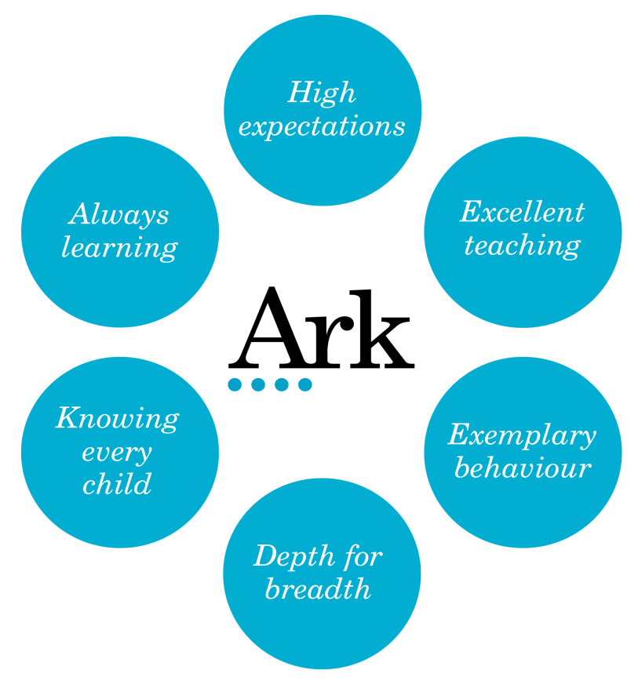

- High Expectations

Students will develop the characteristics that support their academic achievement and will become thoughtful citizens who make good choices in their lives. We set very high expectations for all our pupils, whatever their starting point. We believe every child can realise their potential with the right teaching and support. Progress, from every starting point matters to us. We want every child at Ark Academy to do well enough by the age of 18 to go to university or pursue a career of their choice. We ensure that our pupils understand the wide variety of opportunities and pathways that are available to them.

We hold high expectations for all our pupils. Nothing is as important as the work we do to impact on the learning and lives of our students. Pupils understand the opportunities Ark Academy offers them and that we will do whatever it takes to help students achieve their goals. High expectations and the drive for strong outcomes permeate the school. Pupils and teachers understand that qualifications are the key and we are unapologetic in our pursuit of this. Our teachers are relentless in their efforts and know that co-planning, coaching and forensic assessment are key to the success of our students. We take every opportunity through our extended curriculum and community engagement to ensure that our students grow and develop as well rounded, passionate and curious citizens. We know that children need to think deeply and more broadly about the world around them. We commit to ensuring every child enjoys a range of experiences that develops their social capital and develop their knowledge and their development as citizens in a democratic society. We ensure this through a variety of opportunities and programmes including our strong careers and enrichment programmes. Additionally we develop the learning habits that underpin academic success. Our students learn to think rigorously and creatively, read analytically, organise themselves, manage extended projects, debate and present themselves with confidence.

- Excellent Teaching

Teaching and learning is the main thing. The promotion of high quality learning is at the heart of all our endeavours. We aim to inspire a future of passionate historians, mathematicians, scientists by delivering challenging and engaging lessons. Our teachers have excellent subject knowledge and are passionate about challenging each child to engage, stretch themselves and develop a love of learning. We use data intelligently to support our planning and ensure teaching is meeting the needs of students and improving outcomes.

Excellent teaching is underpinned by a clear view of pedagogy which promotes expert teaching. Through our lessons we build student understanding and work to ensure that knowledge is committed to the long term memory. Our teachers have a clear understanding of how the learning fits into the broader curriculum. We achieve this through curriculum planning which focuses on progression through the age-related curriculum. The concepts, knowledge and skills necessary to be successful are embedded at each stage so that students can successively access the curriculum as it becomes progressively more challenging.

We ensure consistency of provision and access to learning through our whole school commitment to co-planning. All lessons within a topic are delivered across the whole cohort. All teachers then adapt their plans to meet the learning needs of the class they are teaching but the key learning remains the same. We deliver our medium term plans through Fertile Questions. These knit together a sequence of lessons. The questions are thought provoking, challenging and holistic. We know this approach engages pupils and helps them see the links between concepts and knowledge.
- Exemplary Behaviour and strong ethos based on Civitas

There is a compelling and inclusive moral purpose which drives the school forward and is represented by and reflected throughout the school by our motto and core value ‘Civitas’. All members of our community recognise the meaning and spirit of Civitas and that we strive to reflect it in our daily lives. We want all our pupils to enjoy
school and develop enthusiasm for learning alongside an understanding of their future role in society. Effective management and clear consistent routines ensure that we maximise the time for learning and pupils are taught to be self-disciplined and self-regulating.

Ark Academy is a purposeful place of learning characterised by a respectful, orderly environment where teachers can focus on teaching and students on learning. We support one another and our students by the use of consistent routines. We are compassionately ruthless in ensuring that all students know and understand what is expected of them. Simply consistency is king. We know that routines are a team game and we share and implement practices and routines across the school, working as a team to give our students a consistent experience and create an excellent climate for learning. As a result, our students will know that routines help create an excellent school.

All our students and staff know that Civitas is about being a better human being and developing young community leaders with a passion for social action. We expect our students to develop as role models for those who follow them. We support civitas in a variety of ways but significantly through our relationships. Our reward system is based on the four core values of:
civitas, excellence, persistence and participation.

These permeate our school life and support our vibrant House System which supports team spirit, relationships and a positive school culture.

- Depth for breadth

We prioritise depth for breadth. All pupils will secure firm foundation in English and mathematics and this underpins excellence in the other subjects. Our curriculum is rigorous and knowledge based which is reinforced by regular assessments that cumulatively build students’ knowledge.
We offer a broad range of subjects from Early Years through to KS1, 2 and 3. At KS4 we offer academic pathways alongside a range of practical and creative subjects. In KS5 we offer academic pathways including a strength in enabling subjects at ‘A’ level as well as rigorous and challenging vocational pathways. All pathways and progression through the academy are based on high quality careers and pathway support through, our whole school Ambitions Programme.
Our curriculum is planned backwards in each subject with big ideas (fertile questions) underpinning each area of academic study and building year on year ensuring progressively harder concepts are mastered. More time for English and maths is identified where it is most needed to help pupils catch up.

Our assessments, three times a year, cumulatively test students learning over the year. Revision is built into the curriculum to support our students’ progressive understanding of how to learn independently. We place great emphasis on our review week which takes place after each formal assessment. This enables us to re-teach key aspects and students to fix areas of misconception. This is a key component of our feedback strategy. Alongside high stakes testing, all departments implement a variety of formative assessment and quizzes to test and reinforce their learning and feedback into teaching.

- Knowing Every Child

Ark Academy values the diversity and inclusivity of our school. We know it is important that every pupil knows they are well known by their teachers, so that every individual can flourish. In Ark Academy we explicitly develop through our core values and our unifying motto, Civitas, the character and habits which support pupils’ academic and personal development. Our pastoral system ensures that every child has an adult who will listen to them. Positive relationships between students and adults reinforce a culture where children are safe and maintain excellent behaviour and commitment to learning.

Our pastoral teams and experienced support staff ensure that our pupils are known, understood and cared for. Our pastoral teams meet our parents three times a year and ensure they are aware of the progress and development of their child giving them the holistic view of their child’s school life. We teach character education through our tutor and PSHE programme, reinforced by our assemblies. We support Civitas by the way we greet each other, talk to each other and take on responsibilities. Our positive approach in Ark Academy is supported by our rewards system based on our four core values, our tutor system and the house system.

Our teachers understand the most impactful intervention happens in the classroom knowing the class in front of you and ensuring their need is being met is our key commitment.

- Always Learning in Ark Academy

We put professional development at the heart of what we do in Ark Academy. We are always learning. We are committed to identifying talent and nurturing individuals to create a community of exceptional teachers, highly skilled support staff, thoughtful managers and strategic leaders.
Excellent teaching is underpinned by high quality professional development which supports teacher progression. We are a community of learners. It is in our DNA to talk, observe, plan and reflect together.

Teaching is a craft we can always improve. We invest heavily in our provision of professional development. We know that this is the key to the development of our students and to us as educators. We also recognise that all teachers need their subject knowledge refreshing and developing.
We develop our knowledge and skills in Ark Academy in a variety of ways that link together to provide a wide range of opportunities to learn both on the job and from experts. Our teaching practice is developed through weekly mentoring, the weekly training programme, weekly co-planning meetings, through observation and feedback and, where possible, through co-teaching working alongside more experienced professionals.

Through our talk, training and observation we have a shared understanding and a common language that ensures the consistency of our agreed approach. We know the key conditions needed to create this community of learners are trust, risk-taking, collaboration, co-construction, common goals and shared values. All of these underpin our DNA.

Ark Academy learns it way forward, building in time for collective enquiry, reviewing evidence and continually striving for improvement. We evaluate our learning and support our staff to engage in evaluative, data-driven and strategic thinking related to their role. We also evaluate our learning at key assessment points, documented in The Evaluation of Teaching and Learning (ETAL). This enables individual teachers, subjects/key stages and senior leaders to learn through analysis. We are committed to research and reviewing educational thinking as a learning community sharing articles and best practice through our weekly bulletin and blogs. We believe Ark Academy and Ark Schools provides an excellent talent pipeline. As staff prepare to take on or commence new leadership positions within Ark we support them through ongoing training, coaching others, delivering training and leading co-planning.

As a member of both our region and Ark Schools we have regular opportunities to share practice and train together, attend joint monitoring visits or collaborate within our subject area. We are also a member of The Prince’s Teaching Institute which supports the development of subject knowledge.

ARK ACADEMY SIXTH FORM MISSION STATEMENT
Ark Academy Sixth Form offers the highest quality education to allow our students to pursue the university pathway and career of their choice with confidence in a changing and challenging global community. Learning is at our core, we offer a first class education with a drive towards academic excellence and a desire to create independent learners ready to face university life. We believe in extending and enriching our students, both academically and socially, developing young community leaders with a passion for social action. Our students will develop as role models for those who follow them, they themselves inspiring future year groups of Ark academy Sixth Form. We work tirelessly to ensure our students are world ready, armed with the relevant skills, experiences and achievements to make them stand out from the crowd on application for university and future careers of their choice.
We will:
- Deliver a first class learning environment based on outstanding teaching and facilities
- Provide all students with every opportunity to extend themselves and their thinking of the world in which they live; building a portfolio that will allow them to progress into top flight universities
- Challenge students to do better than good and always accept that there is always room for improvement
- Develop our students as young leaders and role models to act as inspiration for younger members of our community
- Welcome, value and respect all who come to the school
- Hold true to our 4 core values and strive to display them in all that we do
  - Excellence
  - Participation
  - Persistence

ARK Safe Recruitment Procedure

ARK is committed to safeguarding and promoting the welfare of children and young people in its academies. In order to meet this responsibility, its academies follow a rigorous selection process to discourage and screen out unsuitable applicants.

Disclosures
This post is classified as having substantial access to children, and appointment is subject to an enhanced police check of previous criminal convictions (DBS). Applicants are required, before appointment, to disclose any conviction, caution or binding over including ‘spent convictions’ under the Rehabilitation of Offenders Act 1974 (Exemptions) Order 1975. Non-disclosure may lead to termination of employment. However, disclosure of a criminal background will not necessarily debar individuals from employment – this will depend upon the nature of the offence(s) and when they occurred.

Reference Checking
References from the previous and current employer will be taken up for shortlisted candidates, and where necessary employers may be contacted to gather further information

Probation
All new staff will be subject to a probation period of six months (which may, in certain circumstances, be extended by up to 10 weeks). The probation period is a trial period, to enable the assessment of an employee’s suitability for the job for which they have been employed. It provides the academy with the opportunity to monitor and review the performance of new staff in relation to various areas, but also in terms of their commitment to safeguarding and relationships with pupils.

