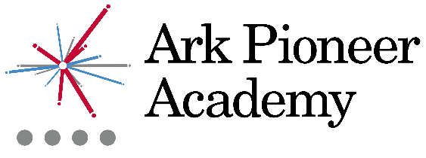
Job Description: Graduate Teaching Assistant

Reports to: SENCO
Start date: September 2019
Salary: TBC

The Role
As a Graduate Teaching Assistant you will support pupils, parents, and teachers, to establish a supportive learning environment in which all children make good academic progress. You will be instrumental in our mission to provide every pupil, regardless of their background, a great education and real choices in life.

Key Responsibilities
Support for pupils
- Support pupil learning through the delivery of specific learning programmes, setting high expectations whilst encouraging their independence and building their confidence
- Promote inclusion, encouraging pupils to interact and work collaboratively
- Work with the SENCO and other teachers to assess the needs of individual children, contribute to and implement Individual Education Plans
- Adapt and develop resources for EAL and SEND pupils, ensuring their safety and enabling them to access the curriculum
- Assist with follow-through for related services including speech/language or physical therapy

Support for the teacher
- Work closely with teachers to assist in the development and delivery of lessons; plan and facilitate one to one teaching and intervention
- Observe, record and feedback information of pupil performance to the teacher
- Use strategies, in liaison with the teacher to assist in behaviour management and to support pupils in their learning objectives

Support for the school
- Supervise pupils in playgrounds, lunchrooms
- Assist with general pastoral care
- Accompany teachers and pupils on trips and out of school activities as required within contract hours, taking responsibility for pupils under the supervision of the teacher
Other
- Maintain pupil and family confidentiality
- Carry out other reasonable tasks as directed by the SENCO

Person Specification: Graduate Teaching Assistant
Qualification Criteria
- Right to work in UK
- Qualified to degree level
- Certified teaching assistant course or training, desirable
Knowledge, Experience and Skills
- Experience establishing successful learning relationships with young people, treating them consistently with respect and consideration
- Good numeracy and literacy skills
- Good administrative, organisational and computer skills
- Excellent communication and interpersonal skills with children and adults
- Able to deal with minor incidents, first aid, and pupil’s personal health and hygiene
Personal Characteristics
- Genuine passion and a belief in the potential of every pupil
- Deep commitment to Ark’s mission of providing an excellent education to every pupil, regardless of background
- Helpful, positive, patient and caring nature
- Able to take direction but also make good judgments and take initiative when required
- Resilient and motivated to continually improve standards and achieve excellence
Other
- Commitment to equality of opportunity and the safeguarding and welfare of all pupils
- Willingness to undertake training
- This post is subject to an enhanced DBS check

Ark is committed to safeguarding and promoting the welfare of children and young people in our academies. In order to meet this responsibility, we follow a rigorous selection process. This process is outlined here, but can be provided in more detail if requested. All successful candidates will be subject to an enhanced Disclosure and Barring Service check.

