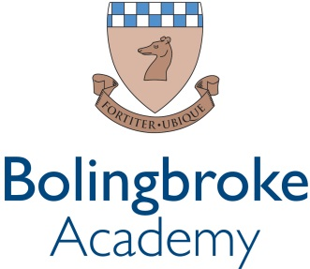

Science Teacher
An exciting opportunity has arisen for dedicated teacher to develop their experience within our passionate and ever courageous community.

We are a courageous, compassionate community - empowering excellence. We are a value lead organisation, being bold within every aspect of our lives at school.
We want all staff to thrive, modelling leadership and determination to the pupils and students within our rich and diverse academy, working together to fulfil our vision of creating a centre of excellence within our local community.
We empower our teams by valuing the individual and prioritising professional development. This is delivered through weekly CPD sessions, dedicated line management meetings and by encouraging staff to develop their own ideas and projects, within their departments and beyond.
Bolingbroke Academy is a uniquely exciting, fulfilling and innovative place to work, learn and grow.
An exciting opportunity for a Science Teacher has arisen for a candidate of exceptional ability to join our dedicated team. We are seeking someone to share our vision and lead our students with courage and determination. This is an opportunity to show what non-selective education can achieve for all pupils and students in our community.
Reports to: Head of Science or Key Stage Lead
Start date: Easter 2024/September 2024
Contract: Permanent – Part-time or Full-time
Salary: £37,667 - £48,857 (Ark MPS AM1 – AM6)
Closing Date: 12th April 2024, 4pm

Key Responsibilities
Leadership and Management

- Have experience of Science teaching at Key Stage 3 and 4 and preferably Physics, Chemistry or Biology at Key Stage 5
- Be an outstanding teacher, able to motivate and challenge learners of all abilities across Key Stages 3-4.

Strategic Activities
- Plan, resource and deliver lessons and sequences of lessons to the highest standard that ensure real learning takes place and pupils make superior progress.
- Develop plans and processes for the classroom with measurable results. Interpret and develop results to make improvements in pupil achievement.
- To review and evaluate current exam boards against Ark standards.

Teaching and learning
- Exude a passion for the subject which is evident in their day-to-day classroom practice.
- To design an engaging and challenging curriculum that inspires pupils to appreciate the subject and its application and which meets the needs of the pupils.
- To deliver outstanding teaching and learning of Science, thereby helping pupils achieve excellent academic results.
- Have a proven track record of success and raising pupil attainment in Science.

School ethos and culture
- Be committed to Bolingbroke Academy’s ethos of high expectations.
- Demonstrate high levels of ambition and optimism regarding what the Academy and its pupils can achieve.
- Provide a nurturing classroom and academy environment that helps students to develop as learners.
- Enrich the curriculum with trips and visits to enhance the learning experience of all pupils.

Person Specification
- Have a passion to learn and develop your practice through regular CPD and feedback.
- The ability to question and challenge the status quo and find new and progressive solutions to existing systems.
- Have strong experience teaching and achieving great results up to Key Stage 4.
- The ability to work in a way that promotes the safety and wellbeing of students and pupils.

