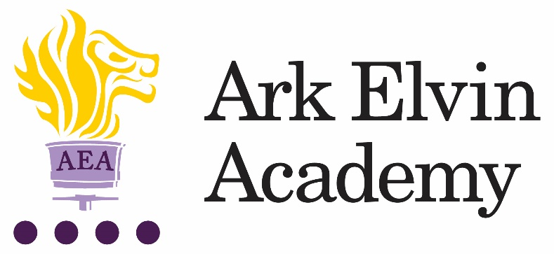

Job Description: Learning Support Assistant for Reading
Reporting to: Head of English
The Role
We are looking for a Learning Support Assistant who has a love of reading and a passion to improve children’s confidence and skill in reading. The role would work within the school’s established English department and EAL team to provide tailored support to pupils who have lower reading ages with the goal of closing the reading age gap and challenging educational disadvantage.

Key Responsibilities
- To deliver tailored interventions for individual pupils ranging from Ruth Miskin Fresh Start Phonics, supporting students with Lexia reading and one to one reading opportunities.
- To provide reading support for students with identified gaps.
- To work with our English team to support students reading development.
- To support assessment and monitoring of our reading intervention provision.
- To update pupil records as required
- To share information about individual pupils with teachers and other colleagues so that all colleagues understand differentiation needs and how best to support learners.
- To prepare additional resources for pupils as required.
- To carry out duties around the school to support the smooth running of the school and promote school values.
- To carry out additional interventions and assessments as required, e.g., reading tests and phonics interventions.

Other
- Undertake other various responsibilities as directed by the Principal

This job description sets out the main duties of the post at the time of drafting. It cannot be read as an exhaustive list. These responsibilities will be discussed annually as part of the postholder’s annual performance review and are subject to change. However, it may be altered at any time subject to need in consultation with the postholder subject to the Principal’s approval.

Person Specification: Learning Support Assistant for Reading

Qualifications
- Right to work in UK
- Good literacy and numeracy
- Degree level qualification (ideally 2:1 or above) English preferred
For those interested in training to teach:
- GCSE math’s and English at grade C or above or equivalent (this a national requirement to enter teacher training)

Knowledge, Skills, and Experience
- Experience of establishing successful learning relationships with a variety of children at the relevant age
- Experience and/or understanding of the role of a learning support assistant
- Relentless drive to do whatever it takes to ensure all pupils succeed.
- Embody our core values – integrity, courage, community, and mastery – in all aspects of work and conduct.
- The belief that with the right environment all our pupils can excel at university, or in a meaningful alternative.
- The courage and conviction to make a difference.
- The ability to listen and communicate effectively.
- Empathy and the ability to understand the needs, aspirations and motivation of diverse individuals and groups.
- The ability to influence and motivate others.
- Develop and communicate a shared vision.
- Model desired behaviour and values.
- Empower, support and coach others.
- Hold others to account for high standards of performance.
- Understand and resolve conflict.
- Identify, analyse, and resolve problems and issues.
- Develop plans with concrete outcomes and effective solutions.
- Evaluate results and identify necessary actions.
- Make fact-based decisions.

Personal Characteristics
- Sustain energy, optimism, and motivation in the face of pressure and setbacks.
- Stay calm in difficult situations and maintain clarity of vision.
- Be adaptable in the face of adversity.
- Awareness of own strengths and limits.
- Commitment to ongoing improvement and learning.
- A passion for own role and that of others.
- Focus on achieving challenging goals and results.
- Resourcefulness and flexibility in delivering outcomes.
- Effective team worker and leader.
- Demonstrates resilience, motivation, and commitment to driving up standards of achievement.
- Acts as a role model to staff and students.
- Vision aligned with Elvin’s high aspirations, high expectations of self and others.

Other
- Commitment to equality of opportunity and the safeguarding and welfare of all students
- Willingness to undertake training.
- This post is subject to an enhanced DBS check.

Ark is committed to safeguarding and promoting the welfare of children and young people in our academies. To meet this responsibility, we follow a rigorous selection process, details of which can be provided if requested. All successful candidates will be subject to an enhanced Disclosure and Barring Service check.

