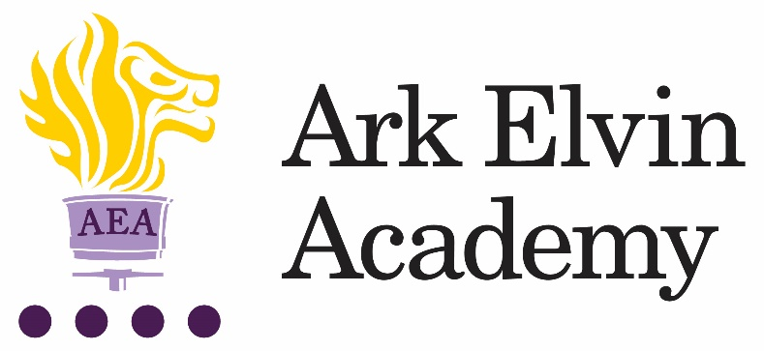

Art Technician

At Ark Elvin Academy we are working hard to provide all our pupils with an excellent education and are looking for committed teachers and support staff to join us at this exciting stage in our school improvement journey. Our team of enthusiastic, high expectations staff have transformed our school and we are just as excited about the next step in our school improvement journey as we work together to deliver the outstanding education our community need and deserve. We are deeply committed to our mission:

“To ensure that every pupil leaves Elvin confident, articulate, and culturally aware; able to pursue careers they are passionate about, contribute to society and live happy, healthy and fulfilled lives.”

In our last OFSTED inspection (October 2019) it was recognised that Ark Elvin Academy:

“Pupils, parents and staff all agree that Ark Elvin Academy has improved out of all recognition. Pupils are proud of the school.”

“The headteacher and leaders have very high expectations…… Staff want all pupils to succeed in every area of their lives, not just academically.”

“The school is a calm, safe and supportive place for pupils. Pupils behave very well in lessons. They get on well with one another and with adults.”

We are a large non-selective secondary school in the London borough of Brent, with excellent transport links to central London. We are committed to ensuring teachers can focus on teaching and have the opportunity to refine and develop their practice in the classroom and develop their leadership skills, we have:

- twice as many training days as is standard
- weekly professional development for all staff.
In recruiting our next Art Technician, we are seeking the following from applicants:

- A passion for their subject, curriculum development and teaching and learning
- A commitment to serving our diverse community in Brent
- High expectations for themselves and our pupils
- A keenness to learn and develop both as a teacher and a leader
- A team player with high standards of professionalism and courteousness.
You will become part of a close knit professional community of enthusiastic colleagues who benefit from the training, guidance and support from both the Ark network, one of the country’s top performing school groups and our North London region of schools where we work closely with four outstanding schools; Ark John Keats Academy, King Solomon Academy, Ark Academy and Isaac Newton Academy.
We passionately believe in our six pillars and they drive all our thinking and our school improvement at Elvin:

Strong Discipline
Calm, purpose, and order are established through the consistency of expectations and explicit teaching of discipline.

High Quality Teaching
Teachers are subject experts with an excellent understanding of the intellectual journey they are taking their pupils on and have mastery in effective teaching skills.

Mastery Curriculum
Our curriculum design enables pupils to make rapid progress and develop a framework of knowledge and understanding in each subject area that provides a solid foundation for further study.

Raising aspirations and enrichment
Pupils understand the opportunities that a school and university education will afford them in terms of careers and quality of life. Pupils develop their passions and interests through an Our extensive enrichment programme.

Character development
Pupils develop the characteristics that support their academic achievement, create thoughtful citizens and allow them to make reflective choices over their personal lives.

Developing leaders
All members of staff see themselves as leaders within an aligned community of professionals and are systematically trained in best practice. We create high performing teams to drive our school improvement.

Ark Elvin is on an exciting improvement journey – join us and be part of that change.

Interested in finding out more? Please email our HR advisor, Chantel: c.mutongole@arkelvinacademy.org for an initial conversation and to arrange a call with our principal, Rebecca Curtis.

Closing date: |  | 30th September 2021
Interviews: |  | On a rolling basis
Start date: |  | As soon as possible
Salary: |  | Scale 4 point 3 £22,607 (pro rata) (actual salary £21,511.56)

Ark is committed to safeguarding children; successful candidates will be subject to an enhanced DBS check
Job Description: Art Technician

The Role
To support the preparation and delivery of the curriculum for Art.
To ensure that the learning environment (classrooms and display boards) are up to date.

Key Responsibilities
- To prepare (and where appropriate manufacture) teaching materials, resources, and models as required to ensure effective support for teaching staff in the department
- To monitor standards and practices within the classroom and identify and communicate improvements to working practices to ensure the highest standards are achieved
- To assist with inventory of equipment and stock control in order to maintain a supply materials. Order stock as directed by the Head of Department so that resources are adequate for lessons
- To liaise with suppliers in the repair and maintenance of all machines and equipment
- To prepare and store materials in order to ensure classes are well equipped
- To receive and check deliveries of supplies to ensure accuracy from suppliers
- To provide technical assistance and information in the classroom and across the school community in order to support pupils and colleagues
- To support pupils in the classroom environment to assist in the learning process where appropriate
- To maintain well organised teaching and preparation rooms
- To maintain and create safe and tidy storage areas and storage systems
- To demonstrate practical making techniques to groups of students and teachers and be willing to learn new techniques and deliver as necessary
- To assist classroom teachers as directed to produce creative displays for the department that can be used to enhance classroom practice
- To work with the Head of Department to organise departmental safety audits
Other
- Undertake other responsibilities as directed by the line manager
Person Specification: Art Technician
Qualification Criteria
- Right to work in the UK
- Qualified to degree level or proficient to A-Level standard in art
Knowledge and Experience
- Awareness of the latest Health & Safety regulations
- Experience of working with secondary school aged children
- Use of Microsoft Word, Excel and PowerPoint
- Knowledge of health and safety requirements, to ensure a consistently safe working environment

Personal Characteristics
- Genuine passion and a belief in the potential of every pupil
- Ability to relate to young people and adults in the learning environment
- Helpful, positive, calm and caring nature
- Respectful of different experiences, ideas and backgrounds of the members of the whole school community
Skills and attributes
We are looking for these skills and attributes or at the very least, a candidate’s clear, demonstrable capacity to develop them:

Alignment with Elvin vision
- Relentless drive to do whatever it takes to ensure all pupils succeed.
- Embody our core values – integrity, courage, community and mastery – in all aspects of work and conduct.
- The belief that with the right environment all of our pupils are able to excel at university, or in a meaningful alternative.
- The courage and conviction to make a difference.

Communication skills
- The ability to listen and communicate effectively.
- Empathy and the ability to understand the needs, aspirations and motivation of diverse individuals and groups.
- The ability to influence and motivate others.

Working with others
- Develop and communicate a shared vision.
- Model desired behaviour and values.
- Empower, support and coach others.
- Hold others to account for high standards of performance.
- Understand and resolve conflict.

Problem solving
- Identify, analyse and resolve problems and issues.
- Develop plans with concrete outcomes and effective solutions.
- Evaluate results and identify necessary actions.
- Make fact-based decisions.

Resilience
- Sustain energy, optimism and motivation in the face of pressure and setbacks.
- Stay calm in difficult situations and maintain clarity of vision.
- Be adaptable in the face of adversity.

Results and learning orientation
- Awareness of own strengths and limits.
- Commitment to ongoing improvement and learning.
- A passion for own role and that of others.
- Focus on achieving challenging goals and results.
- Resourcefulness and flexibility in delivering outcomes.

Leadership
- Effective team worker and leader.
- Demonstrates resilience, motivation and commitment to driving up standards of achievement.
- Acts as a role model to staff and students.
- Vision aligned with Elvin’s high aspirations, high expectations of self and others.

Other
- This post is subject to an enhanced Disclosure and Barring Service check.

