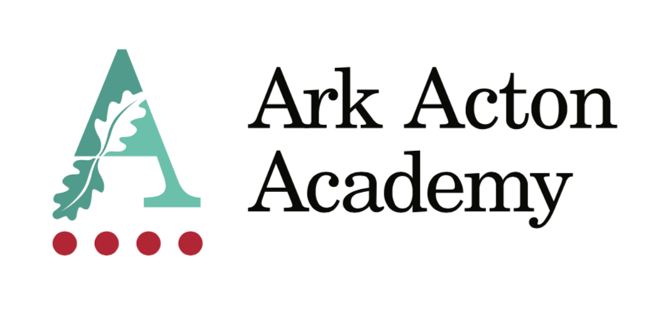

Executive Assistant to Principal

Candidate Information Pack

May 2021

Dear Applicant,

Thank you for taking the time to find out more about Ark Acton Academy. This pack is intended to give you information about the role and our school’s vision. Further information on our vision and approach is available at www.arkacton.org

Ark Acton Academy is an 11-18 Academy situated in the heart of Acton. We are on an incredible improvement journey and we are sowing the seeds of greatness for our local community. We are located in a purpose-built building with exceptional facilities and a warm and collegiate atmosphere.

At Ark Acton we put our staff first. We have looked at all of the elements of work that can cause stress and sought to remove them from our daily experience.

We believe that working at Ark Acton Academy is great fun and we are proud of our diverse team. If, after reading the enclosed information, you would like to apply, please complete our online application form. If you have any queries about the role, please contact Ruth MacMurray – rmacmurray@arkacton.org and she will be able to answer your questions or set up a call with me.

I look forward to receiving your application and welcoming you to our Academy.

Yours sincerely,

Oli Knight
Principal

Executive Assistant to Principal – Job description

Job Title: Executive Assistant
Reports to: Principal
Responsible for: Working as the ‘right hand’ to the Principal and providing them with effective operational, administrative and strategic support in all aspects of school management.
Start date: September 2021
Salary: Ark Support Grade 9 £33,473 - £39,459
Disclosure level: Enhanced

Key responsibilities

- To act as a gatekeeper and first point of contact within the school for staff, governors, parents and others seeking contact with the Principal.
- To organise and manage the Principal’s diary, arranging internal and external meetings, assisting with prioritisation and providing papers and reminders of events and deadlines.
- To ensure the Principal’s time is used optimally and that he is adequately briefed on matters to be discussed as necessary.
- To assist the Principal in organising his administrative workload, recommending items to be dealt with in order of priority; to ensure that the Principal responds to particular tasks within timescales identified in any agreed priority action list.
- To prioritise requests received by the Principal and answer queries as appropriate, referring more complex and/or sensitive matters to the appropriate member of staff.
- To provide care for the Principal’s visitors, including preparation of agenda for visits/meetings, welcoming guests and providing refreshments.
- To ensure the maintenance of clear and effective paper/electronic recording and filing, records and other systems and keep them updated.
- To collate and prepare information and reports for meetings and to take the minutes as required.
- To support the pupil admissions function of the academy through oversight of the in-year admissions process.
- To manage the school calendar ensuring events are accurately inputted and clashes avoided.
- To manage communication to parents through letters, email, texts and the academy website.
- To manage the staff, leave of absence process to ensure known staff absence is planned into the weekly academy schedule.
- To manage the academy exclusions paperwork and record-keeping.
- To line manage and provide quality professional development for the reception manager.
- To provide some personal PA support to the Principal.
- To undertake other various responsibilities as directed by the Principal.

Person Specification

Education/Qualifications:

- Degree
- Permitted to work in the UK

Experience:

- Previous experience in an Executive Assistant/ Personal Assistant or secretarial/administrative role
- Experience of working in a fast-paced environment
- Experience of line managing administrative staff is desirable
- Minute taking experience
- Experience working for a school or at least an understanding of education and how schools work is desirable

Knowledge, Skills & Key Competencies:

- A high degree of inter-personal awareness, including initiative, diplomacy, discretion and a professional approach
- Excellent administrative and organisational skills
- Excellent written and oral communication skills
- High computer literacy with experience using Microsoft Office including Word (advanced), Excel (intermediate), PowerPoint (advanced), and Outlook (advanced)
- Ability to maintain absolute confidentiality and discretion at all times
- A high-level attention to detail is paramount as is the ability to be one step ahead at all times
- Ability to write clearly and concisely and to produce and maintain documents and systems
- Ability to multi-task, prioritise workload and work to meet tight deadlines
- Ability to supervise and manage administrative staff
- Ability to demonstrate flexibility- to deal with changing priorities and/or deadlines
- Ability to problem-solve and be creative when approaching challenges
- Ability to maintain effective relationships and liaise with people at all levels including staff, students, parents, and Governors
- Helpful, approachable and positive nature and ability to stay calm and diplomatic under pressure
- Ability to take initiative and ownership of tasks as well as working with minimal supervision
- Exercise sound judgment, especially relating to confidentiality and discretion
- Keen to learn and further develop own skills
- “Can do” attitude and a willingness to go “above and beyond” your job description and working pattern

This post is covered by Part 7 of the Immigration Act (2016) and therefore the ability to speak fluent English is an essential requirement for the role.

Ark is committed to safeguarding and promoting the welfare of children and young people in our academies. In order to meet this responsibility, we follow a rigorous selection process. This process is outlined here, but can be provided in more detail if requested. All successful candidates will be subject to an enhanced Disclosure and Barring Service check.

