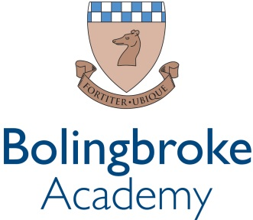

Exam Invigilators

An exciting opportunity has arisen for Exam Invigilators to join our growing Academy
We are a courageous, compassionate community - empowering excellence. We are a value lead organisation, being bold within every aspect of our lives at school.
We want all staff to thrive and demonstrate leadership and determination when leading our students and pupils within our rich and diverse community. We opened in 2012 with the vision to create a centre of excellence in the community.
We are seeking a responsible and exacting Exam Invigilator to join us on a casual contract. The ideal candidate will have excellent communication skills, an attention to detail, abide by necessary examination regulations and the ability to use their own initiative. Experience of working in a school environment and some knowledge of the ‘Instructions for the Conduct of Examinations’ produced annually by the JCQ (Joint Council for Qualifications) would be advantageous but not required.

Closing date: Ongoing
Location: Bolingbroke Academy - Wandsworth, London
Start date: 15th May 2023
Salary: £11.05 per hour
Hours: No set contracted hours - Hours and days will vary according to the Academy’s exam timetable and as required. Availability may be required between the hours of 8am and 5pm, Monday to Friday. Working days will vary between two to seven hours per day.

Our ideal candidate will have:
- Strong attention to detail.
- The ability to follow regulations and processes.
- The ability to act on their own initiative.
- The ability to be firm but fair.
- Commitment to Ark’s ethos of high expectations and delivery
- The ability to work in a way that promotes the safety and wellbeing of students and pupils.

Qualification Criteria
- Right to work in UK.
- A good standard of English and numeracy.

Experience
- Experience of invigilating examinations desirable.
- Previous experience of working in a school environment would be beneficial.
- Some knowledge of the ‘Instructions for the Conduct of Examinations’ produced annually by the JCQ (Joint Council for Qualifications) would be beneficial.

Personal Characteristics
- Reliable and punctual.
- Polite, friendly and flexible approach to work.
- Ability to keep calm and maintain an air of authority.
- Understanding of the importance of confidentiality and discretion.
- Genuine passion for educational opportunities, optimistic view of students and a belief in the potential of every pupil.
- A helpful and positive nature and a calm and caring disposition.
Availability Required (Preferred)

May 15th – June 23rd, 2023 (Summer Public Exam season, there is also the possibility of invigilating mock examinations after this date)
Training
Training in invigilation and examination regulations will be provided to successful candidates by the school prior to May 15th.

